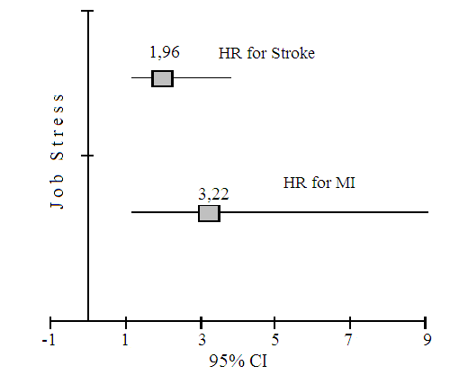
Figure 1. Risk of stroke and myocardial infarction among 25–64-year-old women with high levels of stress at workplace in an open population during 16 years.

