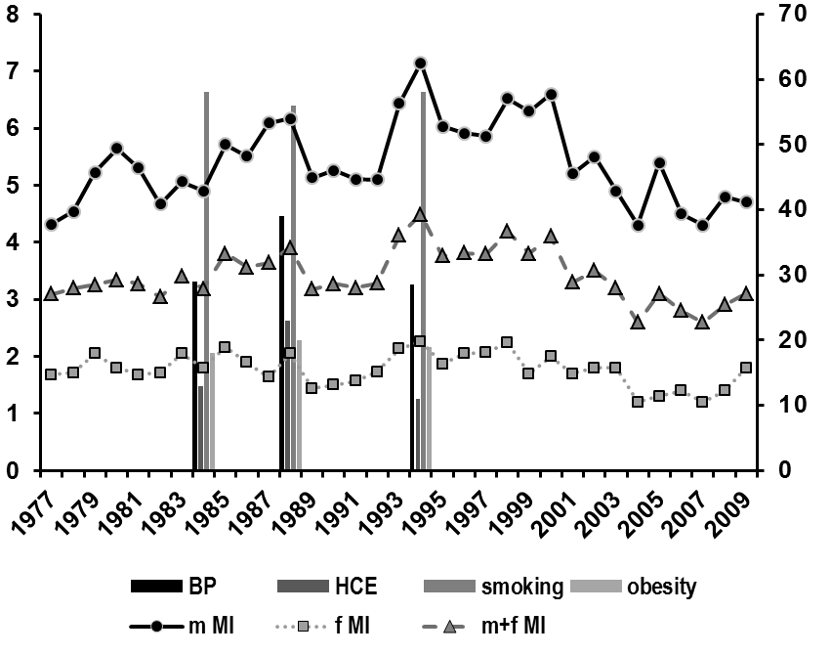
Figure 1. Annual acute myocardial infarction (MI) morbidity rates (per 1,000 population) among 25–64-year-old residents of Novosibirsk and common CVD risk factors (m - male; f - female). *p<0.05; **p<0.01.
Morbidity rate per 1,000
Risk factors, %
*
**
*
*
*

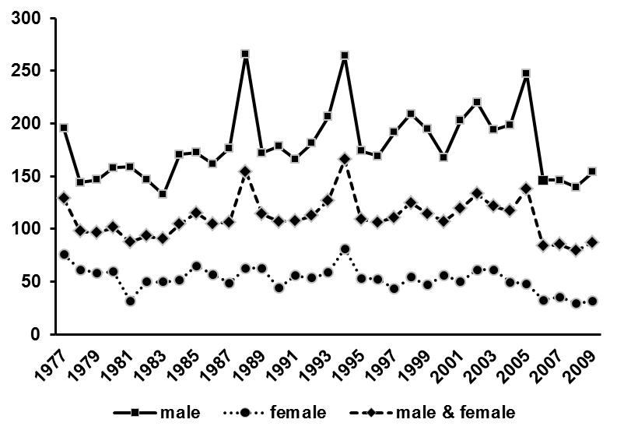
Death rate per 100,000
**
*
**
*
*
*

Figure 2. Annual myocardial infarction mortality rates among 25–64-year-old residents of Novosibirsk (deaths per 100,000 population). *p<0.05; **p<0.01.

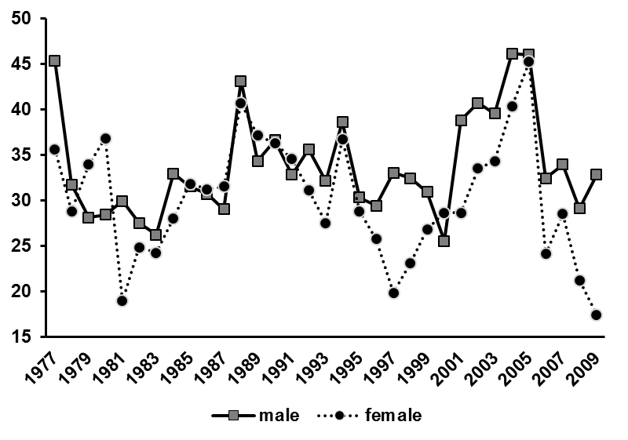
Lethality rate, %
*
*

Figure 3. Myocardial infarction (MI) lethality (%) among 25–64-year-old residents of Novosibirsk. *p<0.05.

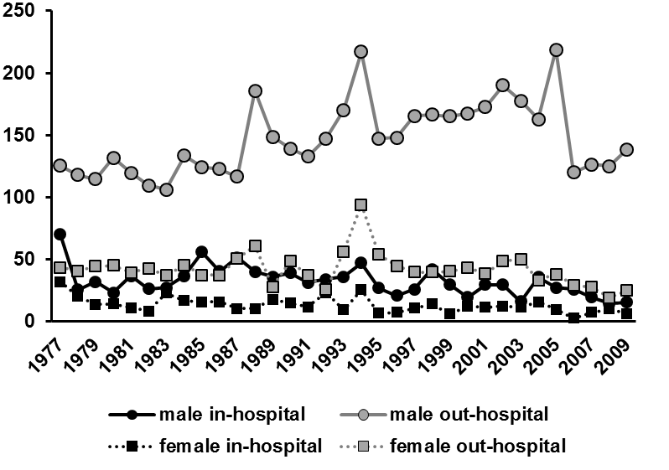
Death rate per 100,000
**
***
***
***
**

Figure 4. Annual myocardial infarction (MI) mortality rates among 25–64 year-old residents of Novosibirsk in regard to site of death (deaths per 100,000 population). **p<0.01; ***p<0.001.

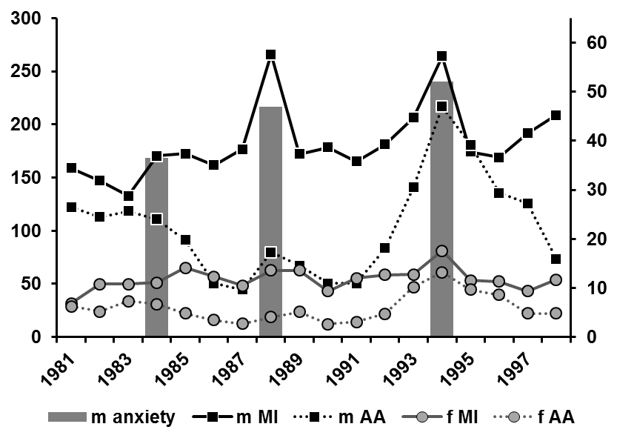
Death rate per 100,000
Anxiety rate, %
***
*
***
**

Figure 5. Annual myocardial infarction (MI) and alcohol abuse (AA) mortality (per 100,000 population) rates among 25–64 year-old residents of Novosibirsk and psychosocial factors (anxiety) in mail. *p<0.05; **p<0.01; ***p<0.001.

